**Online Donation Website**

**Objective**

The objective of the online donation website is to provide a platform for individuals or organizations to create and manage projects that require funding. The website aims to facilitate anonymous donations via multiple payment methods (credit card, cheque, bank transfer) for projects that have specific goals and objectives. It also aims to provide transparency by displaying the number of donors, donation amounts at different thresholds, cumulative donations, and the percentage of donations collected towards the project's final target.

**Vision:** Empowering individuals to make a difference through online donations, fostering a culture of generosity and collective impact.

**Mission:** To provide a user-friendly platform facilitating transparent and diverse charitable projects, enabling seamless contributions through various payment methods**.**

**Understanding of Requirements**

**Functional Requirements:**

1. **Project Creation and Display:**
   * **Allow users to create projects with:**
     + Title
     + Picture (one per project)
     + Description (maximum two pages of text)
     + Photos
     + Links to YouTube videos only
2. **Donation Mechanism:**
   * **Enable anonymous donations by:**
     + Credit card
     + Cheque
     + Bank transfer
   * Ensure ease of donation process, with a maximum of 3-4 clicks for bank transfer or credit card payments.
   * Implement secure payment systems with Pay Plug and PayPal.
   * Do not manage promoter accounts on the website. Each promoter must have an account to collect donations.
3. **Visualization of Donations:**
   * **Display the following information for each project:**
     + Number of donors
     + Amounts donated by threshold:
       - €5
       - €10
       - €20
       - €50
       - €100
       - €200
     + Cumulative donations collected.
     + Percentage of donations collected from the final objective of the collection.
4. **User Interaction:**
   * Disable the feature for users to ask questions for a project**.**
5. **Design:**
   * Web/Mobile Full Responsive design**.**
   * **Highlight features:**
     + Projects on the home page.
     + Project page with contribution details.
     + Minimalist design with a prominent "help" Call to Action.
   * Ensure ease of navigation, especially at the basket level.
6. **Security:**
   * Implement secure payment systems with Pay Plug and PayPal**.**
7. **Web Marketing:**
   * **Email & Notifications:**
     + Send notifications for adding projects, contributions, reminders, and new projects online.
   * **Social Networks:**
     + Interface with social networks for automatic sharing of projects and blog articles on Facebook and Twitter.
   * **Newsletter:**
     + Implement a newsletter feature**.**
8. **Integration for Payment:**
   * Integrate payment systems Pay Plug, PayPal, and Cheque.
   * Provide a mechanism for promoters to activate their secure payment accounts, generating a JSON key that can be copied by the administrator to allow the platform projects to collect donations.

**MoSCoW Prioritization**

**Must have**

* Project creation with title, description, image, and media links.
* Anonymous donations via credit card, cheque, and bank transfer.
* Donation thresholds and cumulative donation display.
* Secure payment integration with PayPal.

**Should have**

* Navigation eases during the donation process.
* Community engagement forum.
* Localization support for languages and currencies.
* Email notifications for project updates and contributions.

**Could have**

* Enhanced project recommendation system.
* Real-time donation tracking.
* Project milestone tracking.
* Interactive project progress visualization.

**Will not have**

* Direct project promoter account management on the platform.
* User question feature for projects.
* Complex project collaboration tools.
* Automated project approval system.

**Workflow:**

User- For the Donar- user journey

1 Sam visited the site.

2 Sam selects the project that he likes.

3 Now Sam can see all the photos and videos related to Project Frost Magic.

4 **He went for a donation and chose to donate 1000 EUR.**

5 **Before payment Sam needs to log in or create an account.**

6 **Now he chooses the credit card to pay and donates the money**.

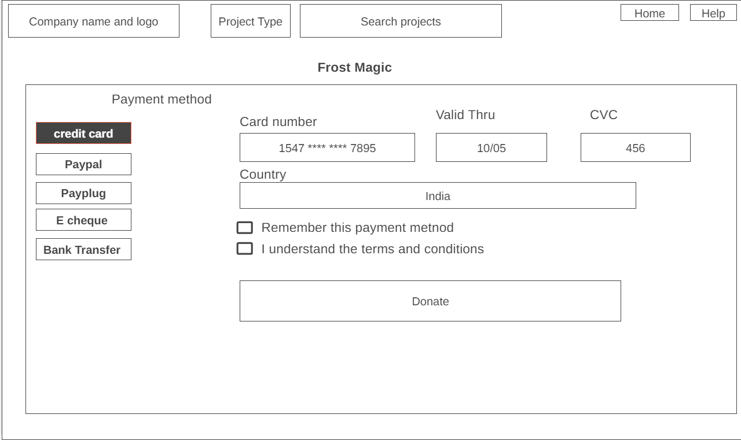

User- For the Fundraiser- user journey

**1 Jim wanted donations for his project, so he clicked on start a new project.**

**2 first he needs to create an account.**

**3 Now he is adding the project's basic details.**

**4 Now he is adding project ideas and a little bit of story.**

**5 Now here he can add a bank account or pay plug for secure payment. A bank account is an additional feature if a person does not have any other payment method.**

**6 Here he is adding the reward per donation.**

**7 On this page the promotion sites are added.**

**Questionnaire**

* What type of projects should be featured on the site?
* How many categories of projects will be available on the site?
* Is there a need for an AI bot on the site?
* Is there a need for user authentication or account creation for donors, or will donations be anonymous?
* How do you plan to gather feedback from users, project promoters, and other stakeholders to continuously improve the website?

**Suggestions:**

* Implement AI to facilitate easier project selection for users.
* Develop a Chatbot to assist users.
* Incorporate a community engagement platform where users can provide feedback and share project ideas.
* Integrate analytics and reporting tools to track project performance, enabling data-driven decisions for future project suggestions, and increasing success rates.
* There should be project categorization and filtering so the user can easily filter the projects.